SPLAB POETRY WORKSHOP

Saturday, November 20

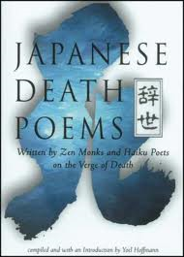
12 to 3pm

Pacific Rim Poetics
… the Pacific Coast of America faces the Far East, culturally as well as geographically…
- Kenneth Rexroth


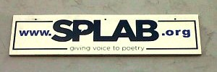
What does it mean to be a Pacific Rim poet? In this workshop, we continue to explore innovative (& classic) Pacific Rim poetics. Poems of the Masters (classic Chinese verse), Japanese Death Poems, Brenda Hillman’s permission to be weird and Andrew Schelling’s post-coyote poetry. Class time will be given to readings (& listenings) of work, as well as writing exercises and discussion. Get a better understanding of your place as a poet in this corner of the world.

SPLAB is in the former Columbia School. ENTER through double doors on Edmunds between Rainier AV S and 36th S. Look for the SPLAB sign. Suggested donation $20, students $10, no one’s turned away.
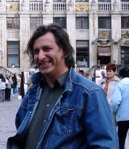
ABOUT facilitator Paul Nelson: Founder of SPLAB, Author of Organic Poetry (essays, Oct. ‘08, VDM Verlag, Germany) & a serial poem re-enacting the history of Auburn, WA, A Time Before Slaughter (Oct. ’09, Apprentice House). Shortlisted for the Stranger Genius Award in Literature, 2010.

