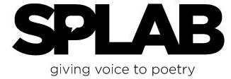
Presents

98118! Represent!

A Day in the Life of America’s Most Diverse Zip Code
Midnight Till Midnight, Wednesday, October 5, 2011

Calling All Poets and Photographers, Professionals and Amateurs
If You Live, Work, or Play in the 98118,
Take Out Your Cameras, Take Out Your Pens, Laptops or I-Pads, Participate!

If Your Business or Organization Would Like to Sponsor a Writer and/or Photographer to Record an Hour or More in the Life of
Your Community on Wednesday, October 5, 2011,
Please Contact: Paul Nelson at SPLAB, 206.422.5002, pen@splab.org
If You Are a Photographer or Poet Who Would Like to Spend
All or Part of Wednesday, October 5, 2011
Recording One or More Perspectives of Life in the 98118,
Please Contact: Nancy Rawles, 206.323.1077, nrawles@earthlink.net

98118! Represent!
is a community arts creation, presentation, and archival project that will include
photography exhibits and poetry readings in 2011 and 2012.
To volunteer services or in-kind donations, please call Nancy or Paul

