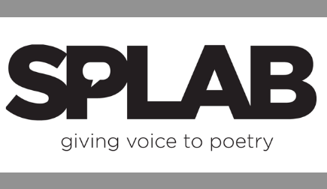
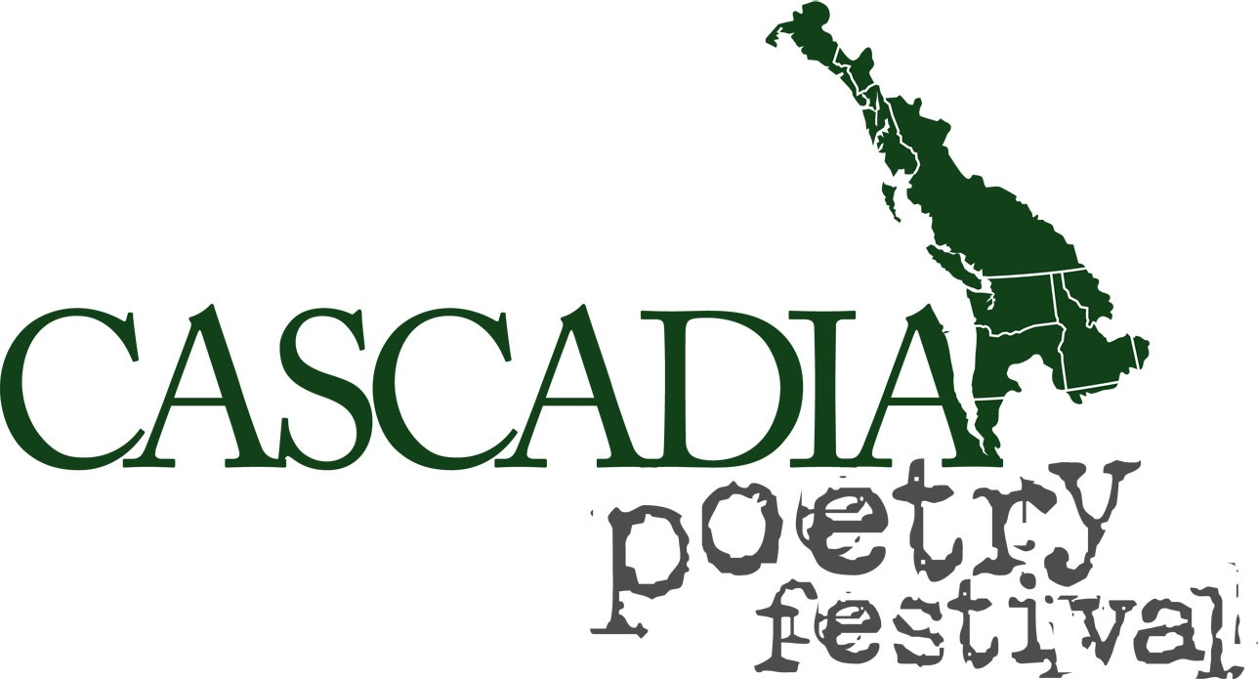
FOR IMMEDIATE RELEASE

SPLAB PRESENTS CASCADIA POETRY FESTIVAL
May 1-3, 2020
on SAN JUAN ISLAND
Tribute to Robin Blaser, The Practice of Cascadia/The Practice of a Life

Seattle, WA, October 11, 2019—Seattle Poetics LAB (SPLAB), a literary arts-oriented nonprofit organization and the organizing entity of the Cascadia Poetry Festival, is presenting the seventh Cascadia Poetry Festival at the Multiverse on San Juan Island May 1-3, 2020. The Multiverse, a gallery and island cultural center, will provide an intimate setting for festival attendees to deep-dive into the intersection of poetics and bioregionalism.

This seventh festival will have a dual focus. First, it is a tribute to Robin Blaser (1925–2009), an important participant in the Berkeley Renaissance of the 1950s, San Francisco poetry circles of the 1960s, and Vancouver circles between 1966 and his death in 2009. A contemporary of poets Robert Duncan, Jack Spicer, and Charles Olson, Blaser contributed to the formation of the serial poem as a dominant mode in postwar New American poetry. Second, the festival is a unique opportunity to delve into the Practice of Cascadia and The Practice of a Life.

Among the poets and scholars scheduled to appear at the festival are former Catholic nun Mary Norbert Körte of Willets, California, Blaser biographer Miriam Nichols of Vancouver, BC, Daphne Marlatt of Vancouver, BC, Sharon Thesen of Kelowna, BC, Bill Yake of Olympia, Washington, Barry McKinnon of Prince George, BC, Thomas Hitoshi Pruiksma of Vashon, Washington, and hosts Jennifer, Gavia and Ian Boyden of the Multiverse.

In addition to poetry readings, there will be two panels and breakout sessions related to Blaser, the practice of Cascadia and the bioregion itself. All-access Gold Passes are $50 and registration is open at Brown Paper Tickets: https://cpf-sji-2020.bpt.me/

SPLAB uses poetics, poetry festivals, publications and education to investigate bioregional culture, building community through shared experience of the spoken and written word. Through the Cascadia Poetry Festival, SPLAB gathers writers, artists, scientists and activists to collaborate, discover and foster deeper connection between all inhabitants and the place itself.

SPLAB, a Seattle-based nonprofit organization, was founded in Auburn, Washington on December 14, 1993. www.splab.org and www.cascadiapoetryfestival.org

###

For more information, contact Paul Nelson at 206-422-5002 or splabman@icloud.com
www.visitsanjuans.com/transportation/getting-here-half-fun

